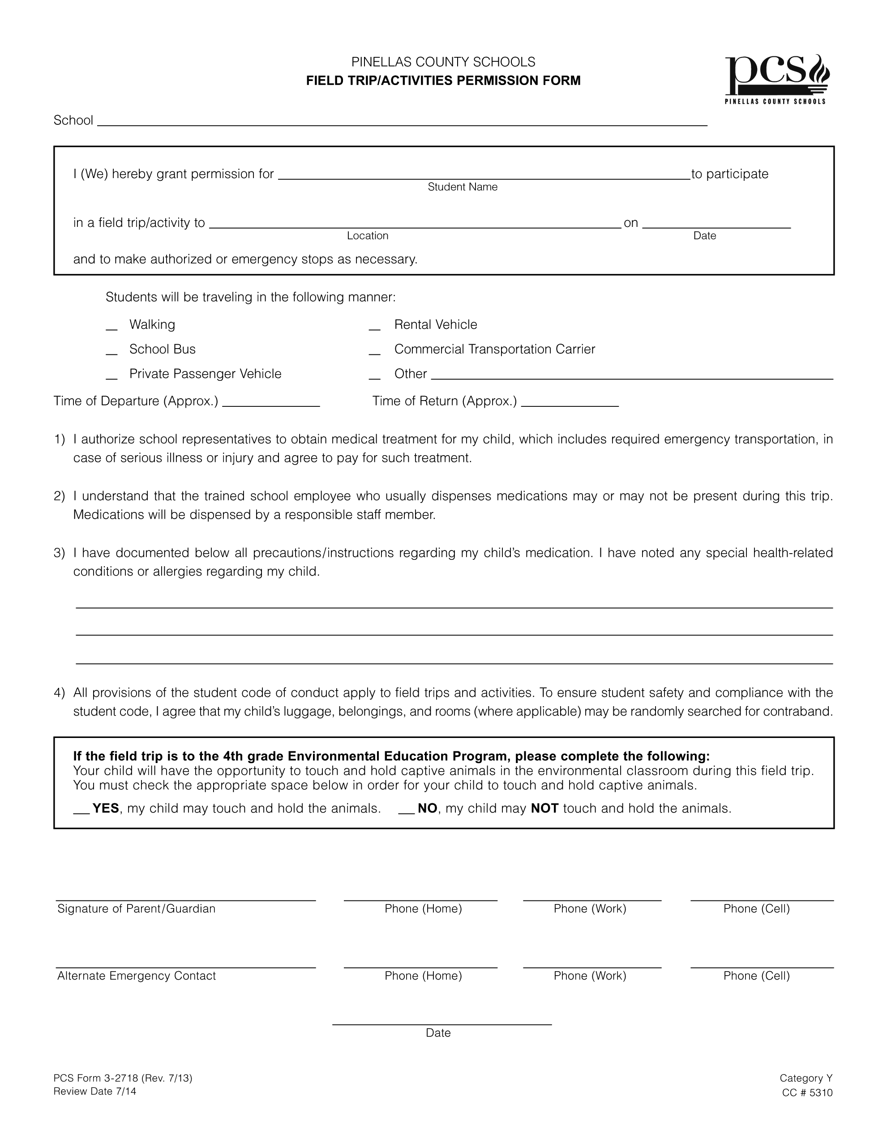

Seminole High School

Career Shadowing (various locations with parental approval) 10/21, 11/11, 1/27, 3/3

X

‘

